Game Design Document

Fill up the Following document.

1. Write the title of your project.

**Pandemic Overthrow**

1. What is the goal of the game?

**To cure the world from Covid-19 by destroying the viruses**

1. Write a brief story of your game?

**You are a bottle of hand sanitizer, but the factory workers gave you a special power. With 3 squirts of your sanitizer, you can cure anyone or destroy one virus. The world is counting on you to save them by banishing all the viruses to an abandoned planet with all the others. If you fail, the world will be completely infested and will crumble killing everybody and destroying humanity forever.**

1. Which are the playing characters of this game?

* Playing characters are the ones which respond to the user based on the input from the user
* Cars, monkeys, dinos, wizards etc, are the playing characters in the game.

|  |  |  |
| --- | --- | --- |
| Number | Character Name | What can this character do? |
| 1 | Sandy Hanitizer | Destroy viruses with 3 squirts. Moved with arrow keys |
| 2 | Sanitizer pumps | Comes out from Sandy Hanitizer when space key pressed |

1. Which are the Non Playing Characters of this game?

* Non Playing characters are the ones which don't have an action or a behaviour when the user interacts with the game.
* Hurdles, stones, bananas, coins, etc are non playing characters in the game.

|  |  |  |
| --- | --- | --- |
| Number | Character Name | What can this character do? |
| 1 | Virus King | Leader of all pandemics and epidemics. Can shoot rapidly and needs 20 pumps to get destroyed. |
| 2 | Viruses | Covid-19. Gets destroyed with 3 pumps |
| 3 | Baby Viruses | Spawns randomly from the viruses |

Draw your imagination of this game. What does this game look like?

* Draw the game either on your computer or on paper,
* Add images of scenes of the game to show each of the playing and non-playing characters at least once.

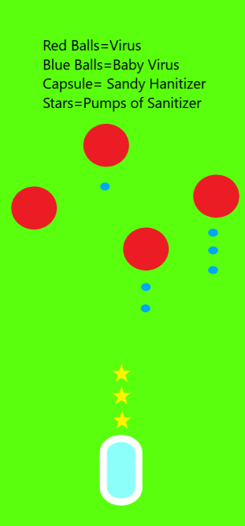

How do you plan to make your game engaging?

**Background Music**

**Sound Effects**

**Random Pumps of Motivation**

**Catchphrases**

**Animations**